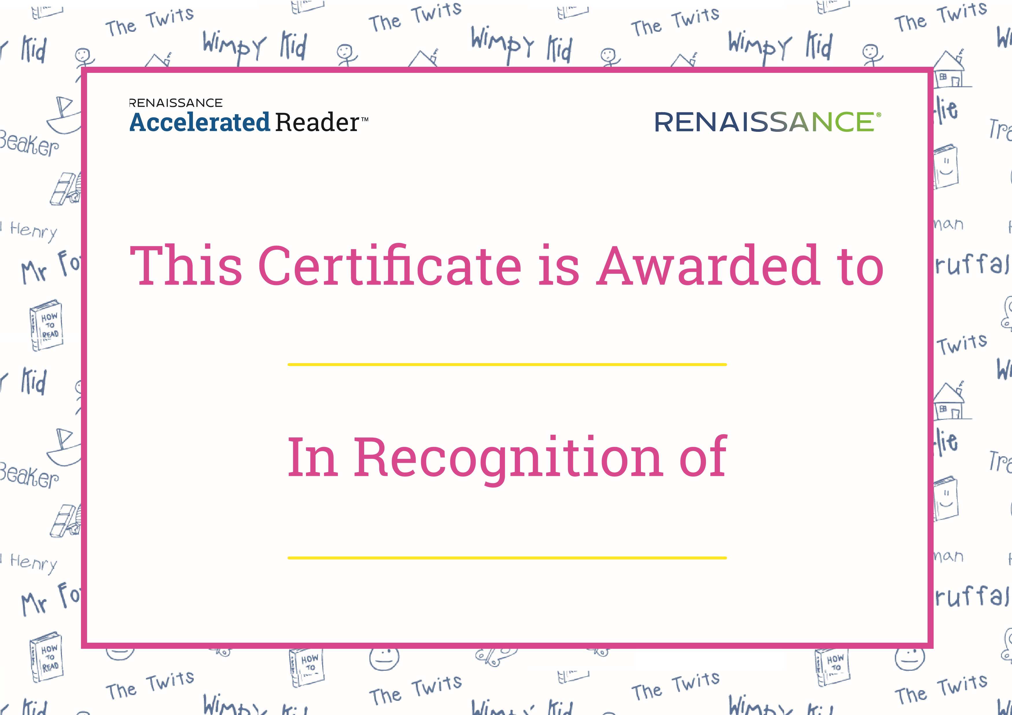

Ollie Mc Gill

Ready Reader 2